©2026 BITREX

BITREX USER MANUAL

 BITREX Official User Guide 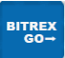
Version 5.0
Earn • Invest • Grow
TO THE KENYAN USER MEMBERSHIP
INTRODUCTION
BITREX is an official company logistics operating through African countries and Japan. The company has been in existence for about Five years. It had a companion with other companies stakeholders such as PANEX and SURPHONE. The company logistics is to transport / or ship the ordered goods to the required points of the city, unlike SURPHONE which refurbish the used/warranted mobile phones to new one(s).
The company overview
The company has develop a platform BITREX to African countries and Japan that helps in running it. For one to be a member of BITREX he/she must sign a contract to the company officials through the portal. The contract period has a minimum of 4 days and a maximum of 365 days (1 year) for then you can decide to sign another one or else. In doing so the company will award you rewards according to the work performance.
For one to participate / work with us, he/she must have a BITREX active and working account. This is where you will be working with the company. He/she must create an account through the portal with the correct user identification.
After creating an account, use the bottom side navigation to go through to the cities. For the first time member you are required to join an INTER CITY for work monitoring and eligibility to work. INTERSHIP has a zero (0) cooperation deposit. Working with INTERN city you are required to do two (2) task per day for a contract period of 4 days which after there will be completed. So you need to navigate to TASK , there you will find different orders of item that are highly and daily ordered , you click CLAIM for only limited number of task per day according to the cities joined. After claiming you will refresh your account for the task bonus to reflect to your account balance. After completion you are required to contact the hiring manager to guide you on how to proceed and how you can withdraw your funds.
OUR OBJECTIVES
The following are the main goals of our company;
- To create employment opportunities among people therefore raising the living standards.
- To create markets for the available resources.
- To promote awareness about marketing and marketing issues.
- To solve/find solutions on marketing problems.
THE GUIDELINES
The following are the steps and procedure on operating/running the platform.
- Creating an Account.
One must sign up a user account through the BITREX BUSINESS PLATFORM where he/she can get access to the company goods.
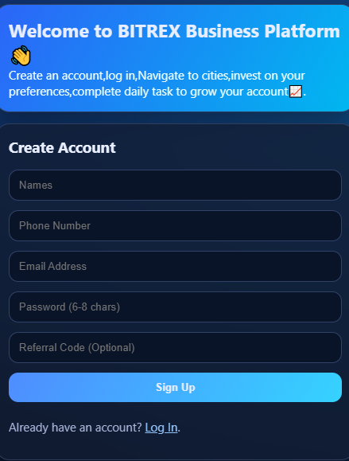
You are required to submit the correct identity to the officials, that is Full Names, Phone Number and Email Adress.
You need to create a 6-8 characters password.
The referral is optional, but it also has rewards.
- Signing in (Log in)
After creating an account you need to log in.
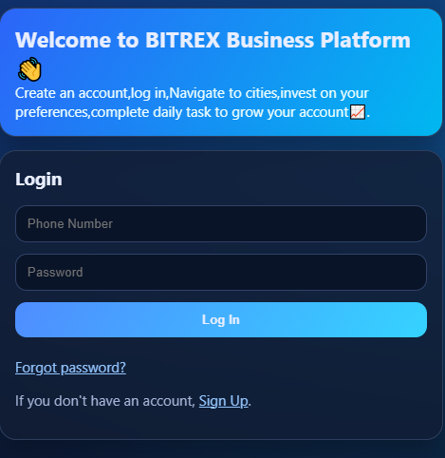
To get access to the platform, You are required to enter the Registered Phone Number and the Password you created.
- Password Recovery
Just in any case you forget your password, on the LOG IN page, just click “Forgot Password?” then it will redirect you to the recovery page
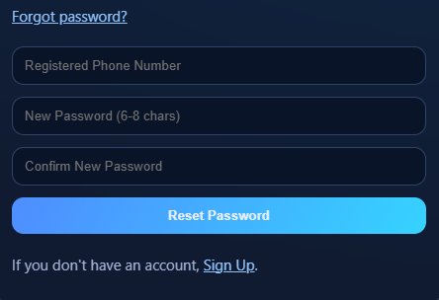
Here you are required to fill the form with ; The Registered Phone Number, New and Confirm New Password.
Your password will reset to new one.

- The Dashboard.
The dashboard will have a number of components
a).The user registration Phone Number, which vary according to the current country.
b).The wallet, which has the Balance, Todays income that is from the daily tasks and finally the Total Earning, which is the total amount since signing the contract.
5. The Wallet Actions
This controls the flow of currency in and out of the account.
DEPOSITS; Also known as Account recharge. This is a cooperation amount of money needed when you need to join a city apart from INTERN. The money makes a trust between the two parties, that is the company and the users.
To top up/deposit/recharge your account you need to input a Phone number with the money and the Amount of funds you need to recharge, then send a Deposit request. After sending Deposit request a message will pop up on your phone declaring the deposit, then you input your pin to continue. Deposited Amount will be automatically reflected to your Account.
NOTE: The minimum amount to be deposited is 300KES.
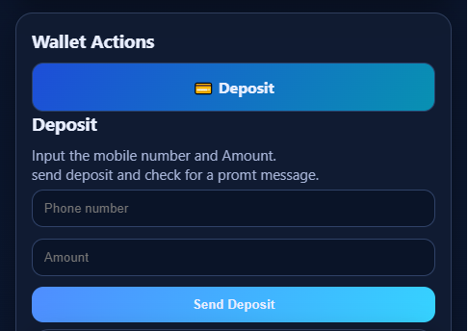
WITHDRWAL; After growing your account you can submit a withdrawal request using withdrawal panel.
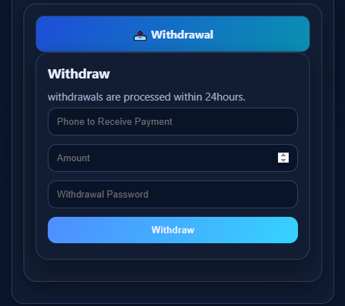
What you need to know is that, you need to input the Phone number that will receive the Payments, the Amount and The Withdrawal password.
NOTE: The Minimum withdrawal is 500KES and it is being processed within 24 hours due to system lag.
The withdrawal password is also the same as log in password.
- Tasking
Each task has a bonus order of 50KES. The company will reward you for submitting an order on their behalf.
NOTE: No one is allowed to place an order without investing or join a working city, therefore task are only for those employees that sign a contract to work for specific cities.
The 50KES is not the buying price of the commodity but the rewards due to order placing.
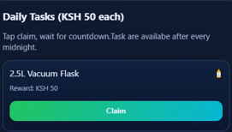
After claiming, the order will be automatically reflected to the Marketing Officials, it will run for 1 minute to place an order. The task are available after midnight/new day therefore there is no multiple placing of one commodity.
Also the city limit routine is followed to avoid placing more orders that the company expectations.
- Cities
The cities you decide to put your shares is being determined by yourself, the higher city demand/shares you buy the more the earnings. Each city contract has a period of 365 days (1 year) EXCEPT the INTERN city, because it test the responsibility of the workers and their habits.
For one to join/invest/buy shares successfully a city, he/she must have a cooperation deposit, then choose city of your preferences, sign the contract then confirm to join as shown below.
A city joined will be displaced at the user dashboard.
NOTE: No one is allowed to invest more than one time in a city. In addition to that you can invest on different cities to maximize your earning.

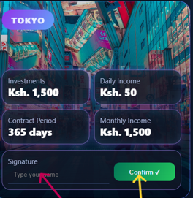
After completing the company contract, you will receive a one time bonus of 99,000KES to each participants of BITREX. From there you can decide to renew the contract and pay 50% less in buying the shares.
- Roulette & spinning.
In spinning wheel has different rewards and it is 100% guarantee winning.
The cash reward will be added to the current user balances.
A new employee is entitle with one free spin, and in addition to that 2 GEMS are required to spin the wheel
- The Menu
The navigation has different components such as employees profile and how to change password, Manager and Working group Whatsapps where you can get helped, and the referrals where you can invite friends and get bonus upon their participation.
TERMS AND CONDITIONS
1. Acceptance of Terms
By accessing and using this platform, you accept and agree to be bound by the terms and provision of this agreement. If you do not agree to abide by the above, please do not use this service.
2. Investment Risks
All investments carry risk. Past performance is not indicative of future results. You should carefully consider your investment objectives, level of experience, and risk appetite before making any investment decisions.
3. Account Responsibility
You are responsible for maintaining the confidentiality of your account and password. You agree to accept responsibility for all activities that occur under your account. Notify us immediately of any unauthorized use.
4. Deposits and Withdrawals
Minimum deposit amount is 300KES. Minimum withdrawal amount is 500KES. Withdrawals are processed within 24 hours. We reserve the right to request verification documents before processing withdrawals.
5. Referral Program
Referral bonuses are when you refer a friend to join a city you earn a one time bonus of ksh300.
6. Privacy Policy
We respect your privacy and are committed to protecting your personal data. We collect and process personal information in accordance with applicable data protection laws.
7. Prohibited Activities
Users are prohibited from: creating multiple accounts, using automated systems, engaging in fraudulent activities, or attempting to manipulate the platform in any way.
8. Termination
We may terminate or suspend your account immediately, without prior notice, for any breach of these Terms. Upon termination, your right to use the platform will immediately cease.
9. Contact Us
If you have any questions about these Terms, please contact our support team or hiring manager.
10. Tasking
For a successive earning, after daily task completion, a screenshot of user account balances and user registration number should be posted to whatsapp working group for complete verification.

©BITREX 2026

